Finding Minerals

As the world population grows, the need for valuable resources grows with it. Some of these resources are normally found deep below us near or in the mantle. One such mineral is the rare element Thomasstoneum. This mineral is rare as it comes up from the mantle. Unfortunately, as crust starts to get weathered, the mineral breaks down and changes into a less valuable mineral, Charlesium. This means that the longer it is on the surface, the less Thomasstoneum is available.

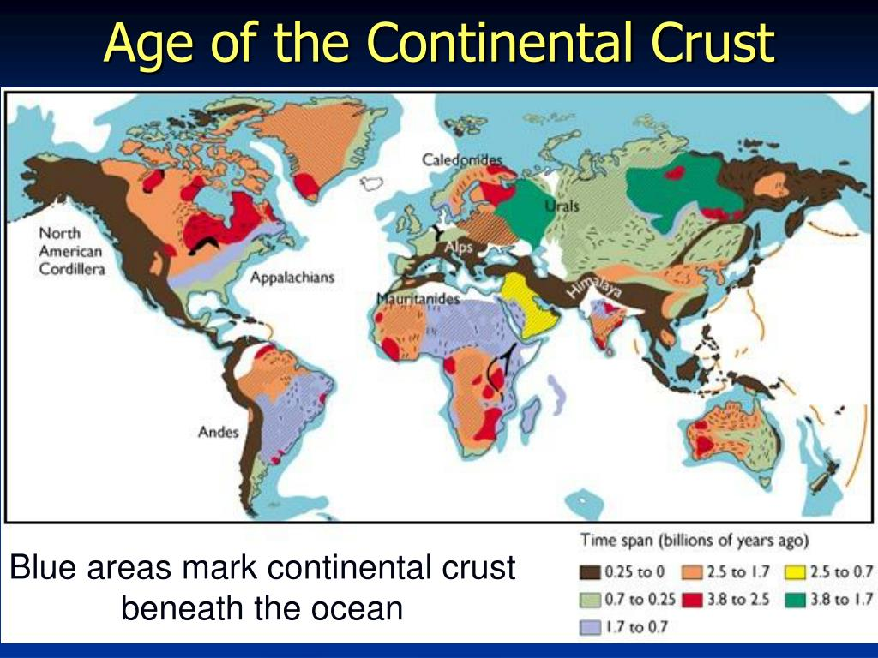

1. Explain how knowing the age of the crust can help mineralogists find deposits of Thomasstoneum.
2. Using the map above, explain where mineralogists would find sources of Thomasstoneum in the United States AND WHY.